Chapter 4 - The role of colour

## Background

In Chapter 3, the role of stimuli distinctiveness on recognition was explored by curating a new set of detailed, real-world object photographs, and comparing recognition performance toward these items with matched line drawn images and written word counterparts. Standard picture superiority effects (PSEs) were observed, with both types of picture producing enhanced recognition performance compared to word stimuli, however, a clear *photograph* superiority effect was also evident when comparisons were made between the photographs and drawings. Such results were attributed to the physical distinctiveness account of the PSE, whereby increased item-to-item variability results in items being remembered better than those with low variability. Studies have previously offered support for this hypothesis by attempting to manipulate the level of variability between items; Ensor et al. (2019a) demonstrated how the PSE could be eliminated by i) increasing the variability between word stimuli, where each item was made more distinctive by manipulations to font, size, and colour, and ii) reducing the variability between picture stimuli, where line drawing items consisted of objects with highly similar shapes, size, and orientation. The current programme of research extended support for this hypothesis by increasing the variability between picture stimuli through the creation of a set of photographic stimuli where differences in detail, texture, and shading were intended to be more apparent across items than they would be across line drawings. While the *photograph* superiority effect (PhSE) demonstrated in the previous study highlights the importance of real world texture and shading in recognition memory, there are other inconsistencies across recognition memory studies with regard to distinctiveness - namely, whether images are presented to participants in greyscale or colour.

The extent to which colour affects the memorability of stimuli is unclear, though there is evidence to suggest this additional layer of information may increase the perceived distinctiveness of items. In a scene recognition paradigm, Suzuki & Takahashi (1997) demonstrated that black & white images may not facilitate successful recognition in the same way as colour images. In an initial study phase, subjects were instructed to passively memorise a number of real-world scene photographs (e.g. train stations, city streets etc.). At test, participants were presented with two photographs side-by-side (one target + one similar lure) and asked to select the item shown during the study phase. The congruency of colour was manipulated, such that photographs were either presented in the same colour modality across both study and test (1. greyscale at study / greyscale at test; 2. colour at study / colour at test) or different (3. greyscale at study / colour at test; 4. colour at study / greyscale at test). Results showed that colour information produced superior recognition performance when presented congruently across encoding and retrieval.Interestingly, this colour benefit was *only* evident in the congruent condition; if colour images were paired with greyscale images - regardless of the order at encoding and test - recognition benefits were absent. A source judgement question at test, probing whether the colour format for each item was the same or different as at study showed similar performance across all four conditions (though performance was particularly poor for items presented in colour); such findings indicate the recognition benefits of the congruent colour condition were not a result of accessing memory for the colour information itself, but rather colour indirectly highlighted certain features within the photographs that were not otherwise noticed as prominently in greyscale, and thus the colour photographs were overall more distinctive as a result.

The current experiment aims to establish whether colour information facilitates successful recognition using object stimuli. The methodology of *Experiment 3* is precisely replicated - whereby recognition is tested across word, drawing, and photograph stimuli - though rather than greyscale items, the sole manipulation of the current study is the addition of colour to the two types of image stimuli. Initial analyses will determine whether the distinctiveness effects of the previous study are also evident when colour items are utilised, and in particular, whether a *photo* superiority effect remains, or if this finding is unique to greyscale stimuli. It is acknowledged that colour may not affect the two types of image in a uniform manner. The highly distinctiveness nature of the photograph items may plateau in such a way that performance can no longer be noticeably enhanced; any additional distinctiveness generated by colour information might show little benefit if performance is already sufficiently high. If this is the case, however, the effects of the colour manipulation should still be evident when examining recognition performance for drawings, where there is more room for such benefits to become apparent. Following this initial analysis, exploratory comparisons will be made to compare the data from the current experiment with that from *Experiment 3*, in an effort to highlight any key differences introduced by the addition of colour. A secondary aim from previous experiments remains, whereby the role of different available response options (*Recollection*/*Familiarity*/*Guessing* or *Recollection*/*Familiarity*/*Both*/*Guessing*) will be examined to establish whether RFG response patterns are differentially affected following the introduction of colour. The following hypotheses are proposed:

1. A photograph superiority effect (similar to that observed in *Experiment 3*) will again be evident, whereby photograph items produce better recognition performance compared to drawings. Based on the results of the previous study, this performance benefit is expected to manifest as:
   * 1. a higher proportion of correct hits;
     2. a lower proportion of false alarms (FAs);
     3. higher overall *d’* scores.
2. Colour information will enhance the relative distinctiveness of image stimuli, resulting in enhanced recognition performance compared to previously utilised greyscale items. Exploratory analyses comparing the results of the current study with those of *Experiment 3* are expected to reveal numerical differences between the colour and greyscale findings, such that the colour items exhibit performance enhancements in the same direction as those outlined in Hypothesis 1 when compared to the greyscale items.
3. Any effects associated with manipulating the availability of response options at test (RFG/RFBG) will remain unaffected by the addition of colour information to image stimuli. Based on the findings of *Experiment 3*, it is expected that:
   * 1. The RFG group will produce a significantly higher proportion of overall hits compared to the RFBG group.
     2. The RFG group will produce a significantly higher proportion of FAs assigned *Familiarity* compared to the RFBG group.
     3. Significant interaction effects between response option and stimuli format will be evident in the analyses of mean *d’* scores, mean proportion of hits assigned *Recollection*, and mean proportion of hits assigned *Familiarity*.

## Experiment: Effect of stimuli format (colour) and response option on recognition memory judgements.

### Method

#### Participants

164 participants completed the experiment online (see Table 8 for a breakdown of the age/gender of the current sample). All participants were required to be between the age of 18-59 years in order to meet our YA criteria (actual range: 18-57). As our experiment involved written words as to-be-remembered stimuli, we also asked that subjects first language be English; the vast majority (96.95%) reported that English was indeed their first language. Subjects were recruited from the voluntary participation website (85.98%), where payment at the rate of £5/hr was given, and via the in-school (14.02%), where they received course participation credits. *G*Power* software was used to calculate an appropriate sample size; to detect a medium effect size of Cohen’s *f* = 0.25 with 80% power (*α* = .05, two-tailed), 79 subjects per group would be necessary (*N* = 158) in a 3x2 mixed ANOVA.

Table 8: Gender and age (*SD*) of the current sample.

#### Materials

Stimuli were the same as those utilised in *Experiment 3*, except the greyscale drawings and photographs were substituted for their colour versions. Items consisted of 126 innocuous, everyday objects (e.g. clock, rabbit, shoe), presented across three individual stimuli formats: written words, line drawings, and photographs. Words and line drawings were sourced from Rossion & Pourtois (2004); the drawings consisted of shaded, colour illustrations, and the words were simply the written names of the depicted objects (these were presented in a clear Sans-serif typeface in the current experiment). A matching set of photograph stimuli were curated in *Experiment 2*; high quality photographs were sourced to similarly depict the same everyday objects as those found in the Rossion & Pourtois (2004) line drawings. In each photograph, the object of interest was isolated from its original background and rotated to match the orientations shown in the line-drawn items. See Figure 16 for examples of each stimuli format.

#### Design

A mixed 3x2 design was utilised, consisting of a within-subjects factor of stimuli format (words, drawings, photographs) and a between-subjects factor of response option (RFG, RFBG). Counterbalancing was achieved via blocked randomisation, whereby participants were presented with: 1) one of six possible study lists (equal length, with the same number of words, drawings, and photographs); 2) one of two possible recognition tests (either RFG: “Recollection”, “Familiarity”, “Guessing”), or RFBG: “Recollection”, “Familiarity”, “Guessing”, “Both”). All counterbalancing routes were of equal length, and subjects were randomly assigned into blocks via balanced methods.

#### Procedure

The procedure was identical to that of *Experiment 3*; data collection was conducted online using the experiment platform . All subjects completed three self-paced phases: i) study phase, ii) distractor task, and iii) recognition test. At study, subjects were instructed to learn each of the word, drawing, and photograph items (shown at random, one-at-a-time) in preparation for a later memory test. For each item, participants were required to report whether the current format was a word, drawing, or photograph - an encoding judgement that ensured attention was directed toward the to-be-remembered stimuli. Next, subjects completed some simple multiple choice mathematical questions (e.g. 6 x 4 = ?) as a distractor task. Finally, participants were presented with the recognition test; word, drawing, and photograph items were once again shown one-at-a-time at random. Half of the test items had been shown previously in the study phase, while the other half were new (not shown at study). Subjects were first required to make an *Old*/*New* judgement, based on whether they believed they had studied the item earlier or not. While *New* judgements simply led to the next item, *Old* judgements led to a follow-up screen where participants were asked whether they had recognised the item via *Recollection*, *Familiarity*, or were simply *Guessing* that it was old. Those in the RFBG response option condition had an additional *Both* option at this stage, where they could report that they had experienced recollection and familiarity simultaneously. Stimuli format stayed the same across study and test (e.g. if the item “penguin” was shown in word format at study, it was also shown as a word at test), and the same concepts were not repeated across the other formats within-subjects (e.g. if the item “penguin” was shown as a word, that subject would not view the drawing or photo version).

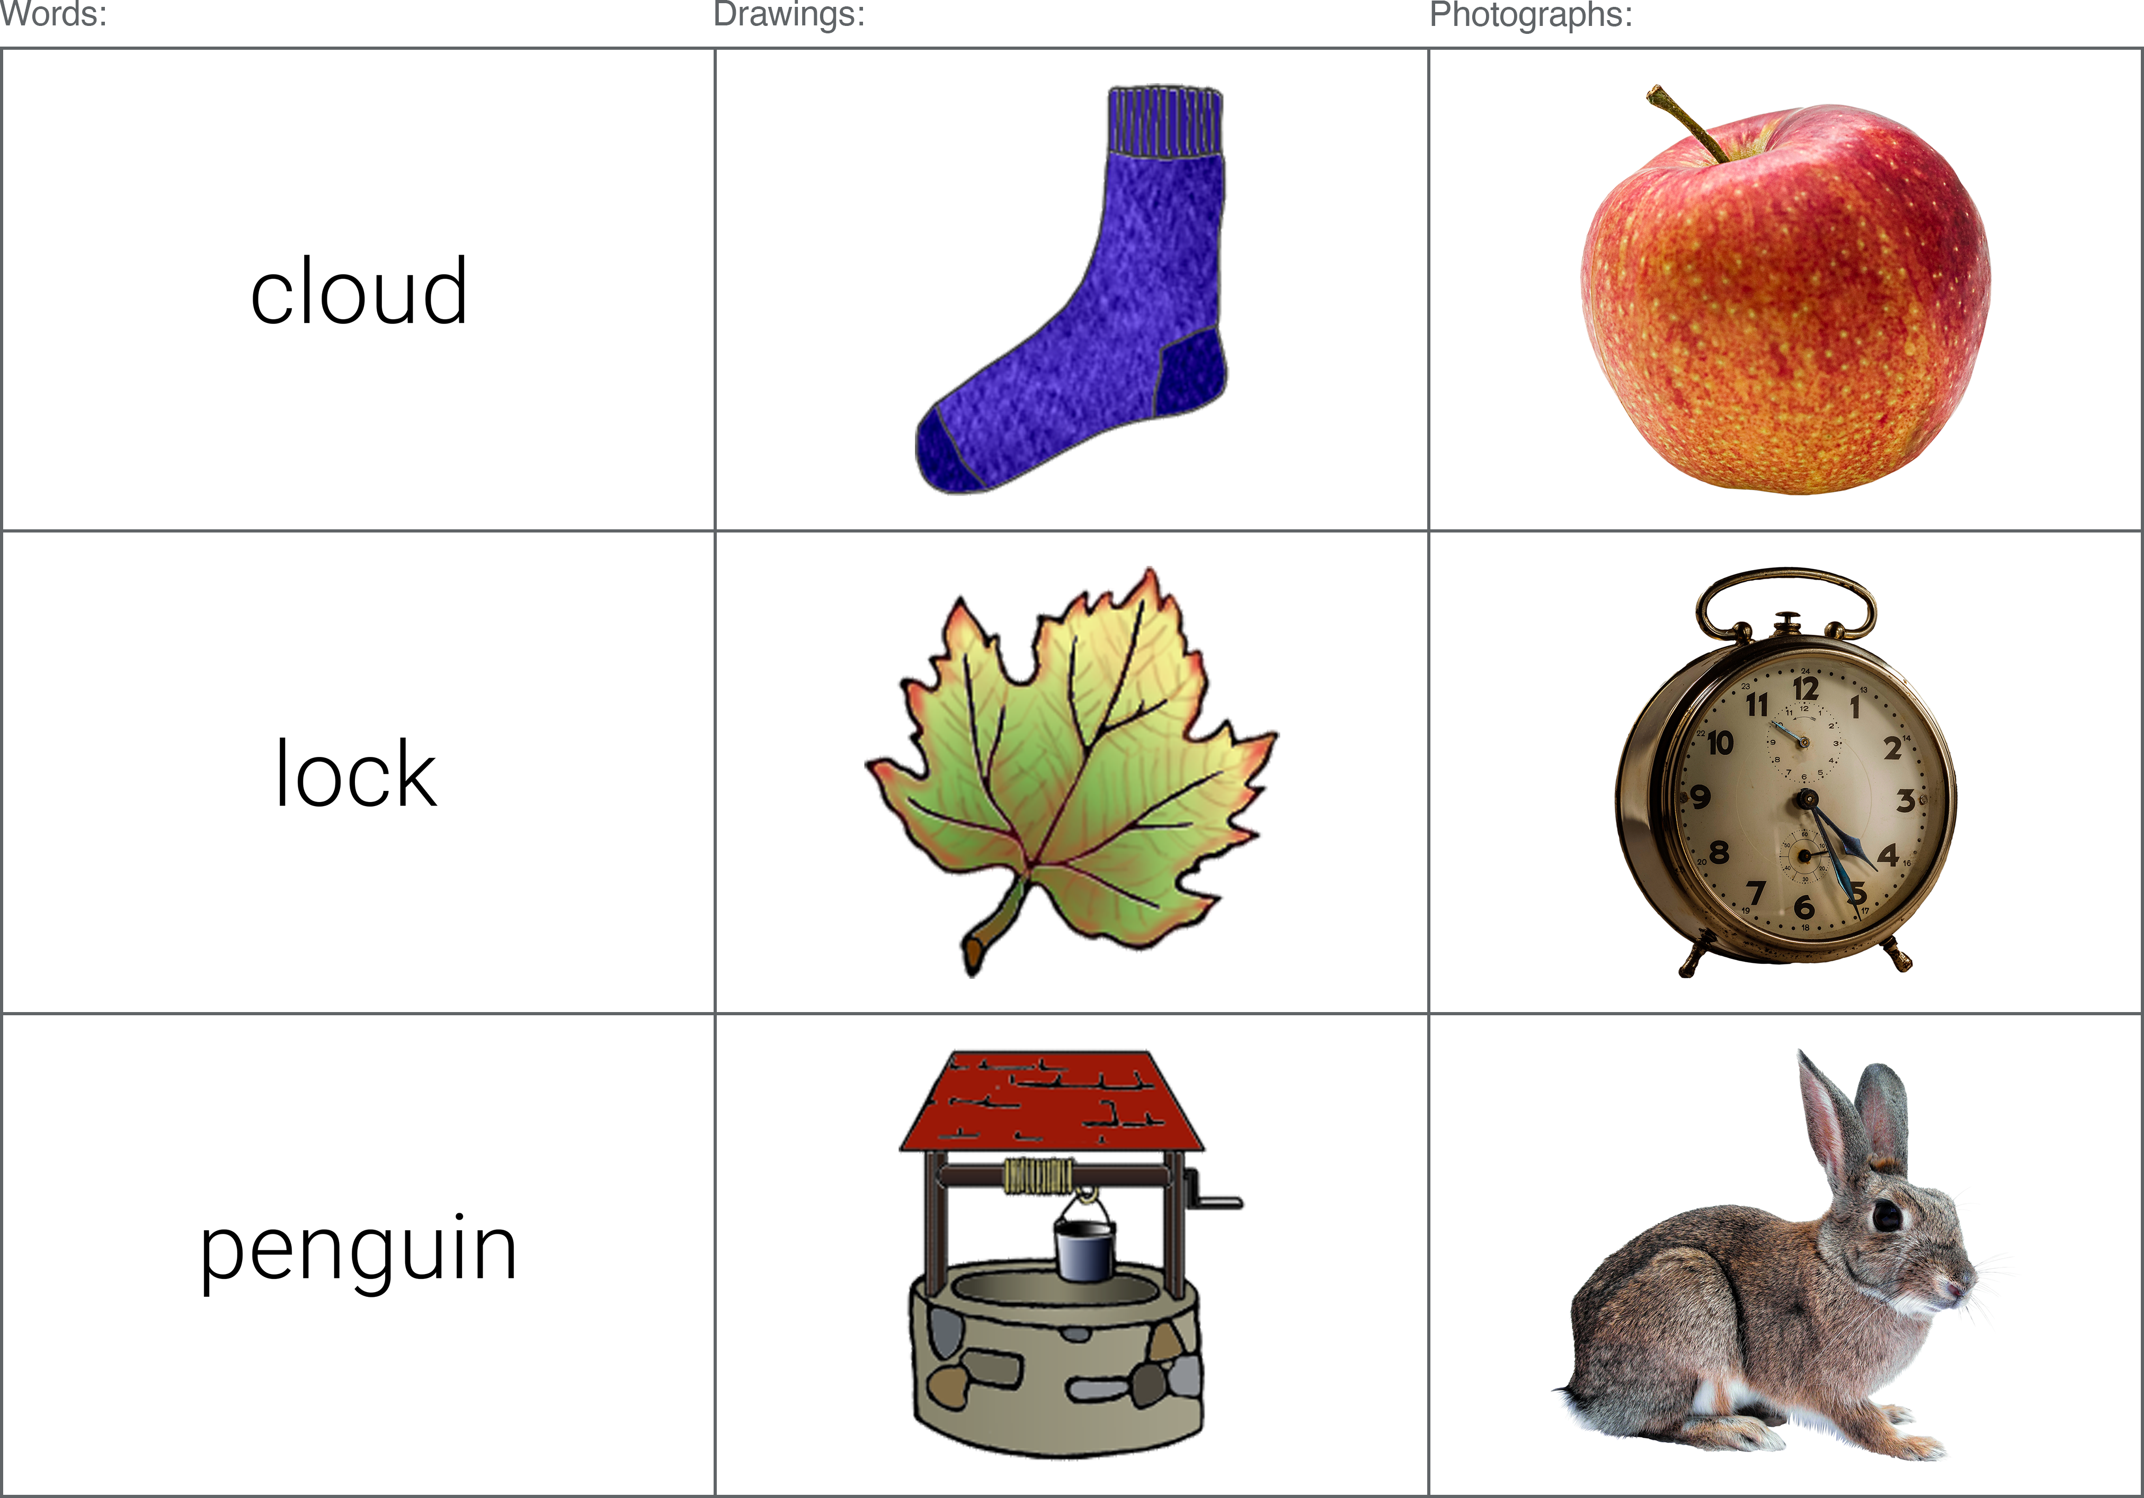 Figure 16: Examples of the word, colour drawing, and colour photograph stimuli utilised in the current experiment.

#### Data processing

The primary DVs of interest consisted of the mean proportion of hits and false alarms (FAs), mean *d’* scores (d-prime, a signal detection measure of sensitivity), and the total number of hits and FAs assigned to each of the available response options (R/F/G or R/F/B/G). Proportions of Recollection and Familiarity were calculated slightly differently depending on the response option condition; in the RFG-judgement group, simple proportions were created from the total number of R responses and the total number of F responses. In the RFBG condition, the proportion of Both responses were added separately to R proportions and F proportions. All analyses were conducted using R (R Core Team, 2020) using the ‘rstatix’ package (v0.6.0; Kassambara, 2020).

Subjects were excluded from analyses on the basis of two key criteria; 1) less than 90% accuracy during the encoding task (“Is this a word, drawing, or photograph?”); 2) extreme z-scores (those presenting z-scores of +/- 3 for total hits, total FAs, or overall recognition [hits minus FAs]). A total of 3 participants were found to meet (at least) one of these criteria, and were thus considered outliers and excluded from analysis, leaving a total of 161 datasets.

### Results

A series of 3x2 mixed ANOVAs were conducted on each of the DVs, with a within-subjects factor of stimuli format (words / colour drawings / colour photos) and a between-subjects factor of response option (RFG / RFBG). Significant main effects and interaction effects were followed-up with Bonferroni-adjusted pairwise comparisons. Greenhouse-Geisser corrections were applied when ANOVA data was found to violate the assumption of sphericity (assessed according to Mauchly’s test statistic).

#### Stimuli distinctiveness

Mean proportions of hits and FAs, and mean *d’* scores are presented for Experiments 3 and 4 in Table 9. Visual inspection of the data shows some expected patterns with regard to stimuli distinctiveness. As the intended distinctiveness increases (from words, to drawings, to photographs), the i) mean proportion of hits increase; ii) mean proportion of FAs decrease; iii) mean *d’* scores increase.

Results from the ANOVAs demonstrated a significant main effect of stimuli format for each of the key variables of interest; hits (*F*(1.70, 271.03) = 187.25, *p* < .001, $η_{p}^{2}$ = .54), FAs (*F*(1.26, 200.79) = 123.14, *p* < .001, $η_{p}^{2}$ = .44), and *d’* scores (*F*(2, 318) = 465.93, *p* < .001, $η_{p}^{2}$ = .75) - though no interaction effects were evident between stimuli format and response option; hits (*F*(1.70, 271.03) = 1.22, *p* = .291, $η_{p}^{2}$ < .01), FAs(*F*(1.26, 200.79) = 2.72, *p* = .092, $η_{p}^{2}$ = .02), or *d’* scores (*F*(2, 318) = 0.20, *p* = .817, $η_{p}^{2}$ < .01).

Table 9: Data from Experiment 3 (using greyscale stimuli) shown alongside that of the current experiment (using colour stimuli), showing the mean proportion of hits, FAs, and mean *d’* scores, by stimuli format and response option condition. Signif. codes: \*\*\**p* < .001; \*\**p* < .01; \**p* < .05; + involved in significant interaction.

To determine whether photo superiority effects were exhibited in the current set of colour stimuli - comparable to those previously observed using greyscale items (Experiment 3) - pairwise t-tests were performed between the colour photos and drawings. For the mean proportion of hits, colour photographs (*M*= 0.87) exhibited a significantly higher proportion than colour drawings (*M*= 0.73), *t*(160) = -11.04, *p* < .001; *d* = -0.87, 95% CI [-1.02, -0.73]. The photographs (*M*= 0.04) also produced significantly fewer FAs compared to drawings (*M*= 0.08), *t*(160) = 6.36, *p* < .001; *d* = 0.5, 95% CI [0.37, 0.64]). Mean *d’* scores were also significantly higher for the colour photographs (*M*= 3.25) compared to the colour drawings (*M*= 2.39), *t*(160) = -13.56, *p* < .001; *d* = -1.07, 95% CI [-1.28, -0.9]. These findings replicate those found previously using greyscale items, whereby photographs offer a number of recognition benefits when compared to less detailed line-drawn illustrations.

Visual inspection of the data (and significant results) reveals only one difference with regard to response option when compared to that obtained in *Experiment 3*: the ANOVA on *d’* scores failed to produce a significant interaction between stimuli format and response option in the current experiment, as was previously demonstrated. Previous follow-up comparisons revealed this interaction was driven by numerically higher *d’* scores for drawings in the RFBG group compared to the RFG group - a deviation from words and photographs, whereby *d’* scores were both higher in the RFG group compared to the RFBG group. The difference between *d’* scores for drawings in the RFG and RFBG groups did not reach significance though, and this negligible difference may explain why such an interaction was absent in the current study.

#### Recollection and Familiarity

To determine the effects of stimuli format and response option on the classification of recognition memory judgements, separate 3 (stimuli format: words, drawings, photographs) x 2 (response option condition: RFG-judgements, RFBG-judgements) mixed ANOVAs were conducted on the mean proportion of hits assigned Recollection, Familiarity, and Guessing (see Figure 17).

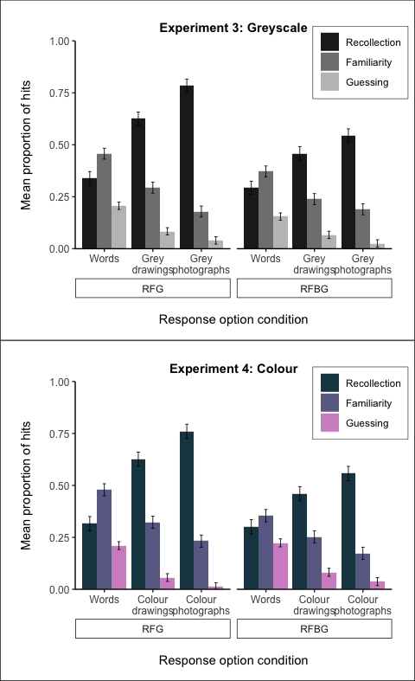 Figure 17: Proportion of hits assigned Recollection, Familiarity, and Guessing, by stimuli format and response option condition.

**Recollection (hits):** Results from the ANOVA on the mean proportion of hits assigned Recollection showed a significant interaction between stimuli format and response option condition, *F*(1.39, 221.56) = 10.79, *p* < .001, $η_{p}^{2}$ = .06 (see Figure 18).

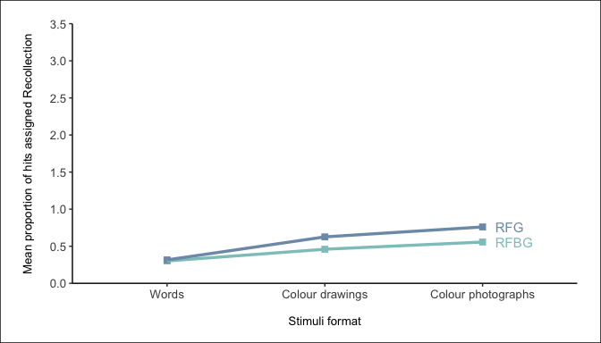 Figure 18: Interaction plot between stimuli format and response option for the mean proportion of hits assigned Recollection.

Comparisons across stimuli formats showed colour photographs produced a significantly higher proportion of R hits than both words and colour drawings in both the RFG group (colour photographs [*M*= 0.76] vs. words [*M*= 0.32], *t*(318) = -15.02, *p* < .001; colour photographs [*M*= 0.76] vs. colour drawings [*M*= 0.63], *t*(318) = -4.53, *p* < .001) and the RFBG group (colour photographs [*M*= 0.56] vs. words [*M*= 0.3], *t*(318) = -8.17, *p* < .001; colour photographs [*M*= 0.56] vs. colour drawings [*M*= 0.46], *t*(318) = -3.11, *p* = .031). Likewise, colour drawings produced a significantly higher proportion of R hits in comparison to Words in both the RFG (colour drawings [*M*= 0.63] vs. words [*M*= 0.32], *t*(318) = -10.49, *p* < .001) and RFBG conditions (colour drawings [*M*= 0.46] vs. words [*M*= 0.3], *t*(318) = -5.06, *p* < .001).

The interaction is evident following comparisons of the same stimuli format across response option conditions. The RFG group produced a significantly higher proportion of R hits than the RFBG group for colour photographs (RFG [*M* = 0.76] vs. RFBG [*M* = 0.56], *t*(274.37) = -4.19, *p* = .001) and for colour drawings (RFG [*M* = 0.63] vs. RFBG [*M* = 0.46], *t*(274.37) = -3.43, *p* = .011). However, this was not the case for words, where there was no difference in the proportion of R hits between the RFG (*M* = 0.32) and RFBG groups (*M* = 0.3; *t*(274.37) = -0.30, *p* > .999).

**Familiarity (hits):** Results from the ANOVA on the mean proportion of hits assigned Familiarity again showed a significant main effect of stimuli format *F*(1.49, 236.15) = 50.18, *p* < .001, $η_{p}^{2}$ = .24. Colour photographs (*M*= 0.2) produced significantly fewer F hits than both words (*M*= 0.42), *t*(160) = -8.34, *p* < .001; *d* = -0.66, 95% CI [-0.85, -0.48], and colour drawings (*M*= 0.29), *t*(160) = 5.97, *p* < .001; *d* = 0.47, 95% CI [0.31, 0.64]. The colour drawings (*M*= 0.29) also showed significantly fewer F hits compared to words (*M*= 0.42), *t*(160) = -5.77, *p* < .001; *d* = -0.45, 95% CI [-0.62, -0.3]. There were no significant interaction effects between stimuli format and response option condition, *F*(1.49, 236.15) = 1.33, *p* = .263, $η_{p}^{2}$ < .01.

**Guessing (hits):** The ANOVA on the mean proportion of hits assigned Guessing demonstrated a significant main effect of stimuli format *F*(1.29, 204.70) = 82.24, *p* < .001, $η_{p}^{2}$ = .34. Colour photographs (*M*= 0.02) produced significantly fewer G hits in comparison to both words (*M*= 0.22; *t*(160) = -10.18, *p* < .001; *d* = -0.8, 95% CI [-0.92, -0.69]) and colour drawings (*M*= 0.07; *t*(160) = 5.5, *p* < .001; *d* = 0.43, 95% CI [0.33, 0.55]). The colour drawings (*M*= 0.07) also showed a significantly lower proportion of G hits compared to words (*M*= 0.22; *t*(160) = -8.41, *p* < .001; *d* = -0.66, 95% CI [-0.78, -0.55]. There were no significant interaction effects between stimuli format and response option condition *F*(1.29, 204.70) = 0.09, *p* = .824, $η_{p}^{2}$ < .01.

Separate 3 (stimuli format: words, drawings, photographs) x 2 (response option condition: RFG-judgements, RFBG-judgements) mixed ANOVAs were also conducted on the mean proportion of FAs assigned Recollection, Familiarity, and Guessing (see Figure 19).

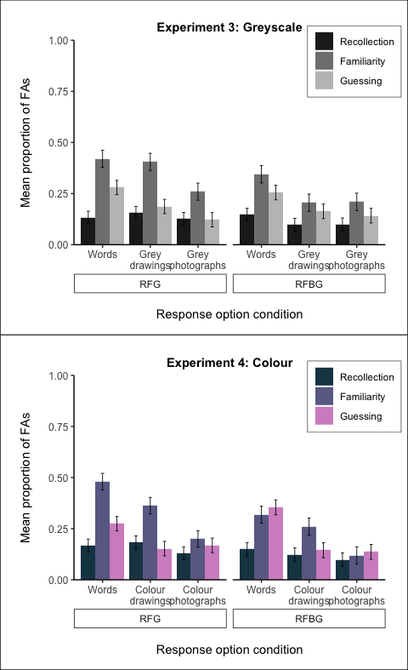 Figure 19: Proportion of FAs assigned Recollection, Familiarity, and Guessing, by stimuli format and response option condition.

**Recollection (FAs):** For FAs assigned *Recollection*, there was no significant main effect of stimuli format [*F*(2, 318) = 1.58, *p* = .207, $η_{p}^{2}$ < .01 or interaction [*F*(2, 318) = 0.32, *p* = .727, $η_{p}^{2}$ < .01].

**Familiarity (FAs):** The ANOVA for FAs assigned *Familiarity* showed a significant main effect of stimuli format, *F*(2, 318) = 22.92, *p* < .001, $η_{p}^{2}$ = .13. Colour photographs (*M*= 0.16) produced significantly fewer F FAs than words (*M*= 0.4), *t*(160) = -6.41, *p* < .001; *d* = -0.51, 95% CI [-0.68, -0.34]. Likewise, colour drawings (*M*= 0.31) also showed a significantly lower proportion of FAs compared to words (*M*= 0.4), *t*(160) = -2.45, *p* = 0.05; *d* = -0.19, 95% CI [-0.36, -0.04]. However, there was no significant difference in the proportion of FAs assigned Familiarity between colour photographs (*M*= 0.16) and colour drawings (*M*= 0.31), *t*(160) = 4.65, *p* < .001; *d* = 0.37, 95% CI [0.23, 0.53]. There were no significant interaction effects between stimuli format and response option condition, *F*(2, 318) = 0.70, *p* = .498, $η_{p}^{2}$ < .01.

**Guessing (FAs):** The ANOVA on the mean proportion of FAs assigned *Guessing* demonstrated a significant main effect of stimuli format *F*(2, 318) = 16.11, *p* < .001, $η_{p}^{2}$ = .09. Colour photographs (*M*= 0.15) produced significantly fewer G FAs in comparison to words (*M*= 0.31), *t*(160) = -4.5, *p* < .001; *d* = -0.35, 95% CI [-0.52, -0.2]). Likewise, colour drawings (*M*= 0.15) also showed a significantly lower proportion of FAs compared to words (*M*= 0.31), *t*(160) = -4.85, *p* < .001; *d* = -0.38, 95% CI [-0.55, -0.24]. However, there was no significant difference in the proportion of FAs assigned Guessing between colour photographs (*M*= 0.15) and colour drawings (*M*= 0.15), *t*(160) = -0.15, *p* = 1; *d* = -0.01, 95% CI [-0.17, 0.16]). There were also no significant interaction effects between stimuli format and response option condition *F*(2, 318) = 1.57, *p* = .210, $η_{p}^{2}$ < .01.

Visual inspection of the data in Figure 17 and Figure 19 demonstrates a highly similar pattern of responding between *Experiment 3* and the current study, and suggest the addition of colour had little impact on RFG response patterns.

#### Response option availability

In each of the aforementioned ANOVAs, the role of response option was also examined to determine whether the addition of colour information had any differential effects compared to the findings of *Experiment 3*. The only main effect of response option was observed in the ANOVA for the mean proportion of FAs (*F*(1, 159) = 1.03, *p* = .312, $η_{p}^{2}$ < .01), whereby a higher proportion of FAs was evident in the RFG group (*M*= 0.13) compared to the RFBG group (*M*= 0.1), *t*(457.34) = -2.43, *p* = .016, *d* = 0.22. Such results do not support Hypothesis 3, where significant main effects of response option were expected in the ANOVAs for the mean proportion of hits and mean proportion of FAs assigned *Familiarity*. Similarly, the expected interactions for mean *d’* scores and proportion of hits assigned *Familiarity* were also absent. The only consistent finding across *Experiment 3* and the current experiment (with regard to response option) comes from the ANOVA for the mean proportion of hits assigned *Recollection* - where a significant interaction between stimuli format and response option was apparent in both experiments; in both experiments, the proportion of R hits did not differ across RFG and RFBG groups for word stimuli, whereas for drawings and photographs, the RFG group produced a significantly higher proportion of R hits than the RFBG group.

    Table 7: Main effects of response option condition across all variables of interest. Signif. codes: \*\*\**p* < .001; \*\**p* < .01; \**p* < .05; + involved in significant interaction [see previous section for interpretation]).

|  |  |  |
| --- | --- | --- |
| Variable | Main effect of response option | Signif. |
| Mean proportion: ***Hits*** | *F*(1, 159) = 2.76, *p* = .098, $η_{p}^{2}$ = .02 |  |
| Mean proportion: ***FAs*** | *F*(1, 159) = 5.25, *p* = .023, $η_{p}^{2}$ = .03 | * |
| Mean scores: ***d’*** | *F*(1, 159) = 0.00, *p* = .993, $η_{p}^{2}$ < .01 |  |
| Mean proportion: ***Recollection hits*** | *F*(1, 159) = 9.42, *p* = .003, $η_{p}^{2}$ = .06 | + |
| Mean proportion: ***Familiarity hits*** | *F*(1, 159) = 6.43, *p* = .012, $η_{p}^{2}$ = .04 |  |
| Mean proportion: ***Guessing hits*** | *F*(1, 159) = 1.10, *p* = .295, $η_{p}^{2}$ < .01 |  |
| Mean proportion: ***Recollection FAs*** | *F*(1, 159) = 1.19, *p* = .278, $η_{p}^{2}$ < .01 |  |
| Mean proportion: ***Familiarity FAs*** | *F*(1, 159) = 8.03, *p* = .005, $η_{p}^{2}$ = .05 |  |
| Mean proportion: ***Guessing FAs*** | *F*(1, 159) = 0.17, *p* = .682, $η_{p}^{2}$ < .01 |  |

### Discussion

The aim of the current experiment was to determine the effects of colour on recognition performance. In *Experiment 3*, recognition performance was found to improve in a linear manner as the intended distinctiveness of greyscale items increased, from words to line drawings to photographs. While standard PSEs were expected, the most notable finding of the previous study was the superiority of photographs compared to line drawings - a result that offered support for the physical distinctiveness account of the PSE over dual-coding theory. In the current experiment, the physical distinctiveness of image stimuli was manipulated through the addition of colour; it was hypothesised that colour would provide an additional layer of distinctive information that would further facilitate successful recognition. When comparing the results of the current study with those obtained in *Experiment 3*, this hypothesis appears wholly unsupported; colour had little to no impact on the proportion of hits, FAs, and overall recognition accuracy.

The current results continue to be best explained by the physical distinctiveness account of the PSE. Across each of the key variables, photographs demonstrated clear recognition benefits compared to drawings, replicating that found in *Experiment 3* and further supporting the notion that the current set of stimuli appear to effectively capture different ‘levels’ of stimuli distinctiveness. The additional real-world detail present in the photographs, and the increased variability between items as a result, provides memorial advantages over simple line drawn representations of objects. The key manipulation in the current study - the addition of colour - was unsuccessful in providing an additional layer of distinctiveness that would further enhance recognition for the objects compared to when they are presented in greyscale. Failure to discern any impact of colour does not seem attributable to ceiling effects, whereby performance is already so high that benefits are imperceivable, since responses toward drawings were equally unaffected by the manipulation.